# MINI PROJECT (2020-21)

**Develop a mobile Application to manage Lost and Found things using Flutter framework**

**MID-TERM REPORT**



**Institute of Engineering & Technology**

**Submitted by- Yash Jain (181500823)**

**Mukul Mishra**

**(181500400)**

***Supervised By:***

**Mr. Akash Kumar Choudhary**

Assistant Professor

# Department of Computer Engineering & Applications

**Contents**

|  |  |
| --- | --- |
| **Abstract** | **3** |
| **1. Introduction** | **3** |
| 1.1 General Introduction to the topic | **3** |
| 1.2 Area of Computer Science | **6** |
| 1.3 Hardware and Software Requirements | **6** |
| **2. Problem definition** | **7** |
| **3. Objectives** | **8** |
| 4**. Implementation Details** | **8** |
| **5. Progress till Date & The Remaining work** | **9** |
| **6. Entity-Relationship**  **7. Use-Case Diagram**  **8. Some Screenshots** | **10**  **11**  **12** |
| **9. References** | **16** |

**Abstract**

During lockdown period I was taking to my friend, who told me that he was unable to fill an internship form and lost a good opportunity as he had lost his college ID card at the campus which he needed to upload in the form. As we were pondering upon the situation, I came across a solution of providing an automated lost-found things management system which will inform everyone about all the lost, found things (if any) and also the genuine claimer can easily claim it from the concerned person. Also, this system will automatically send the notification and information to everyone and if found, you may easily claim it from the concerned person by providing him the right details.

# Introduction

* 1. **General Introduction to the topic**

To develop a mobile application that will be quite helpful in solving the problem of finding the lost things and also to identify the genuine claimer for the same. With the use of this application everyone associated with the campus will always be updated regarding any lost or found item and also if it is claimed or not.

This application will not only ease the task for the concerned person or the department to run it but also help them maintain the record of all items digitally without any manual entry system.

# About Flutter Framework: -

Flutter is a cross-platform UI toolkit that is designed to allow code reuse across operating systems such as iOS and Android, while also allowing applications to interface directly with underlying platform services. The goal is to enable developers to deliver high-performance apps that feel natural on different platforms, embracing differences where they exist while sharing as much code as possible.

During development, Flutter apps run in a VM that offers stateful hot reload of changes without needing a full recompile. For release, Flutter apps are compiled directly to machine code, whether Intel x64 or ARM instructions, or to JavaScript if targeting the web. The framework is open source, with a permissive BSD license, and has a thriving ecosystem of third-party packages that supplement the core library functionality.

# How Hyperledger Fabric Works: -

Flutter is built in a whole new way, compared to other frameworks, working more like a gaming engine, than a traditional application framework. I will go through the high level basics of how Flutter works, and how it delivers the simple, high performance outcome. Starting at a very high level, your app is composed of Widgets, that are rendered onto a Skia canvas, and sent to the platform. The platform shows the canvas, and sends events back as required.

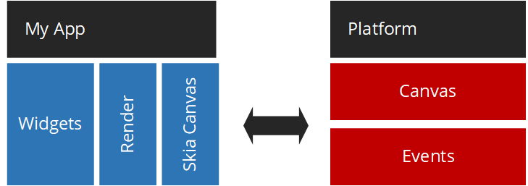

Starting at the platform level, Flutter provides a Shell, that hosts the Dart VM. The Shell, is platform specific, giving access to the native platform APIs and hosting the establishing the platform relevant canvas. There is also an embedder API, if you want to use Flutter like a library, instead of hosting running an app.



The Shells, also help provide communication to the relevant IMEs (e.g. Keyboard) and the systems application lifecycle events.

The engine is the next layer up, providing the Dart Runtime, Skia, Platform Channels and much more. You can see more of what the engine provides in the [architecture diagram](https://github.com/flutter/engine/wiki#architecture-diagram) in the Flutter Wiki.

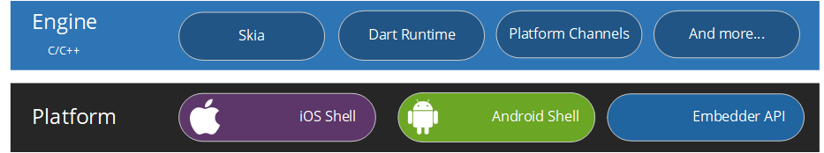

The Flutter engine is run inside the relevant platform Shell.

The Flutter framework is the most relevant to the app developer. It contains everything you will interact with, when developing your app.

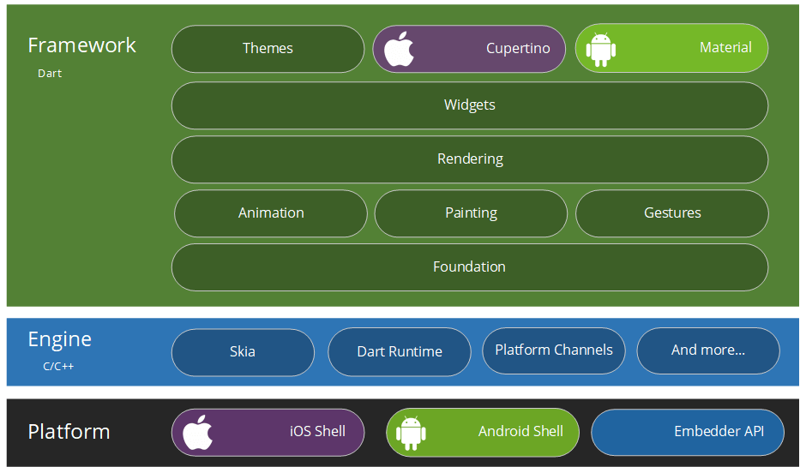

Flutter apps can look like native iOS or Android applications, simply by using the right themes. Cupertino is for iOS and Material is for Android. You can also make your app look however you want, regardless of themes.

# What is Firebase: -

Firebase is Google’s mobile application development platform that helps you build, improve, and grow your app. Firebase is a toolset to “build, improve, and grow your app”, and the tools it gives you cover a large portion of the services that developers would normally have to build themselves, but don’t really want to build, because they’d rather be focusing on the app experience itself. This includes things like analytics, authentication, databases, configuration, file storage, push messaging, and the list goes on. The services are hosted in the cloud, and scale with little to no effort on the part of the developer.

# Area of Computer Science

Initially we will develop this application considering in mind the university campus scenario, now the question arises whether this type of service is required? As of today, the students are following the basic mail procedure or the traditional enquiring about the belonging, which is kind of a hectic and time-consuming process, considering a student’s daily schedule, firstly the mail notification, which to be frank not every student pays heed, then seeking any official who could help is also time taking. So, we thought why not provide a simple application as a solution to this problem and managing the lost and found things so that it could easily be claimed by the right claimer from the concerned person.

Although there are a lot of applications targeting the same scenario of "Lost and Found" but being a college student myself, no such application has come into light. This is initially designed keeping our own university in mind which can further be designed for generic use or for specific campus or demands. Also having an independent application of our own will not only attract the universities or colleges but other areas too.

Not just for university campus but if the project is actually helping to solve the problem, this could be enhanced for various societies, organizations, or campuses as per their specific demand. Also, in future AI & ML can be integrated in it, so that the application can automatically judge the uploaded photo for better details and understanding.

# Hardware Requirements

* + - A computer with minimum 4 Gb of RAM (Windows/Linux/MacOS)
    - Android mobile phone
    - Mobile USB data cable.

# Software requirements

* + - Adobe Photoshop
    - Android Studio
    - Microsoft Visual Studio Code
    - Git
    - Flutter SDK
    - Dia

# Problem Definition

Every college, society or a campus is vast in terms of area as well as number of people existing there. With people, comes their things and belongings and as it is said ‘you are yourself responsible for your belongings’, but what if you found something which would mean nothing to you but for someone it could be their life’s work or something quite valuable.

All campuses have departments for various tasks and concerns but most of them lack the lost-found things department or if it’s there it actually doesn’t work out the solution of the problem due the usual traditional way they follow. Also, there is no concerned person or a specified path for such a problem and to inform everyone regarding the same in most of the colleges and campuses.

So, it is required to develop a system that will manage all the information related to a thing or belonging lost or found by anyone, it’s claim by genuine person and make the process hassle-free and less-time taking for both the person who has lost and who has found it. The system should have the ability to display the sufficient information (not all the details) regarding lost or found things and the genuine claimer could easily collect his/her belongings. Also, the system should keep track and a record of all the lost, found and claimed things encountered till date thereby digitalizing the traditional manual entry system.

# Objectives

* To develop a system that could solve the problem of lost and found things at any campus.
* To make the whole process of uploading the information and sharing it to all automated, easy, less time consuming and hassle-free.
* To display only relevant information regarding a lost thing so that only the actual owner can claim it.
* To ease the process for the concerned person so that he may handle the claiming process genuinely and smoothly.
* To keep a record of all the lost, found and claimed things till present date.

# Implementation Details

**Part 1:** To gather all the requirements for developing this mobile application like: features which will enhance user experience, data related requirements, optimization techniques, etc.

**Part 2:** Design application logo, Entity-relationship diagram for database, and Use-Case diagram.

**Part 3:** Start coding for the first screen that is welcome screen of the application.

**Part 4:** Start coding for the login and signup screen using email and password which will be further authenticated using Firebase.

**Part 5:** Integration of Firebase in the application by registering the app in the firebase console and coding all the required code for authentication, data storage and retrieval from firebase’s collections by applying business logic.

**Part 6:** Start coding for the user dashboard and all the required data integration in it.

**Part 7:** Test the application in various mobile phones and in various scenarios.

**Part 8:** Apply changes (if any) in the application.

1. Part 1 completed.

# Progress

## To gather requirements for the application.

## Features to be included in the application

## Data to be collected from the user during signing up.

## Information to be displayed on dashboard.

## 2.) Part 2 is completed

## Designing App logo, ER Diagram and Use-Case diagram

* Design an attractive app logo using Adobe Photoshop.
* Design the Entity-Relationship Diagram for the application’s database keeping in mind all the necessary attributes, primary keys and relationships using Dia software.
* Design use-case diagram for the application using Dia software.

**Entity-Relationship Diagram**

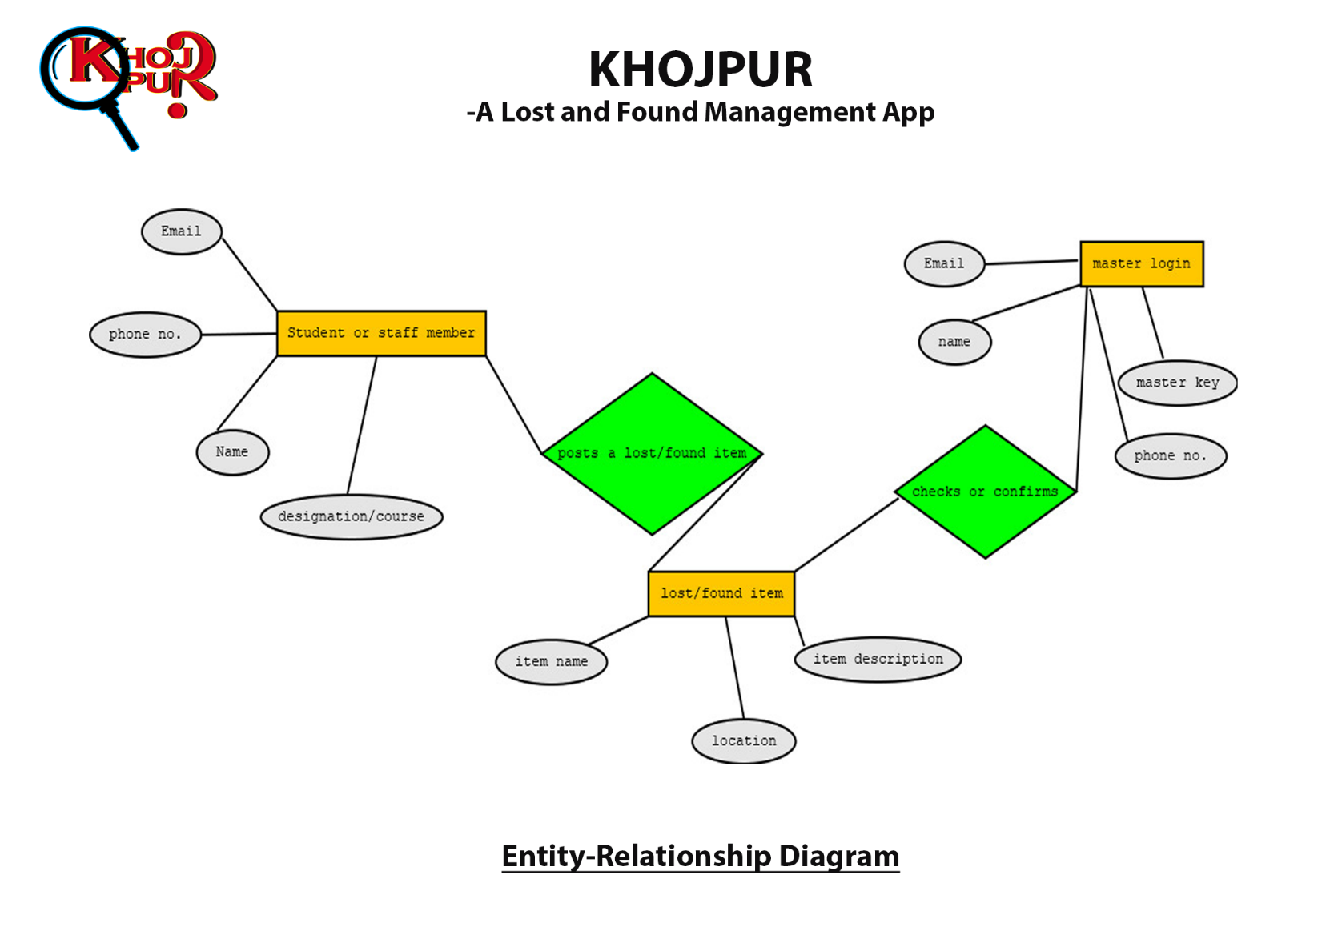

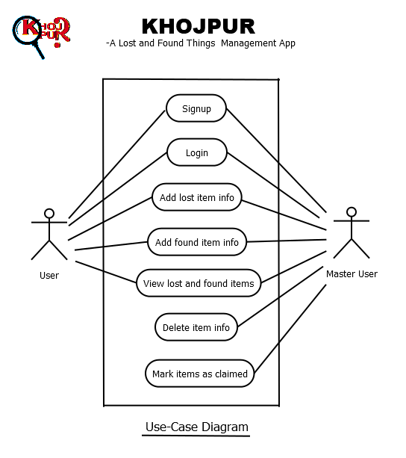**Use-Case Diagram**

# SCREENSHOTS

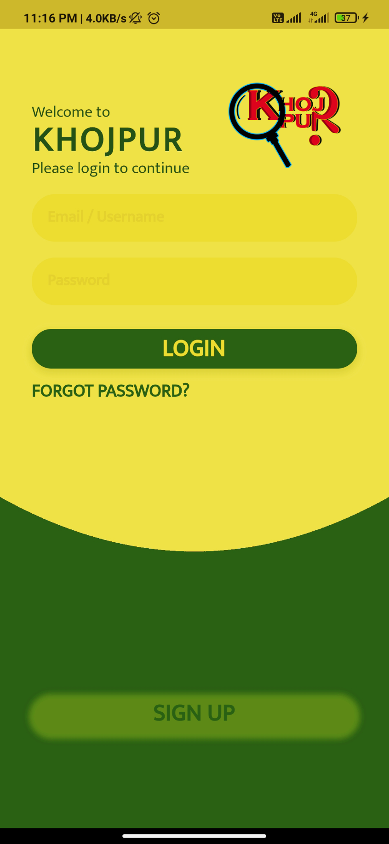

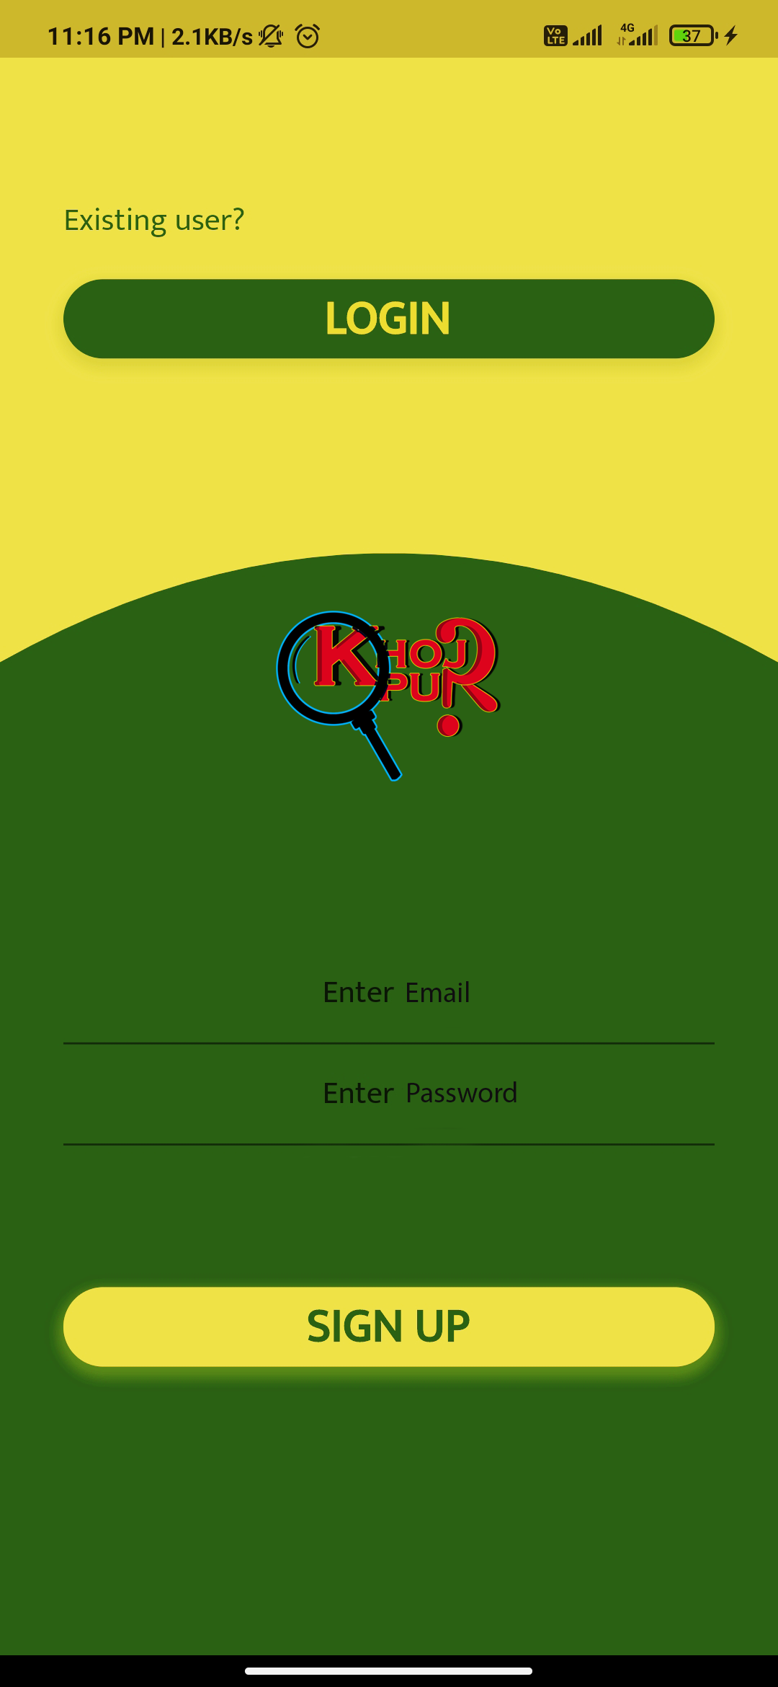

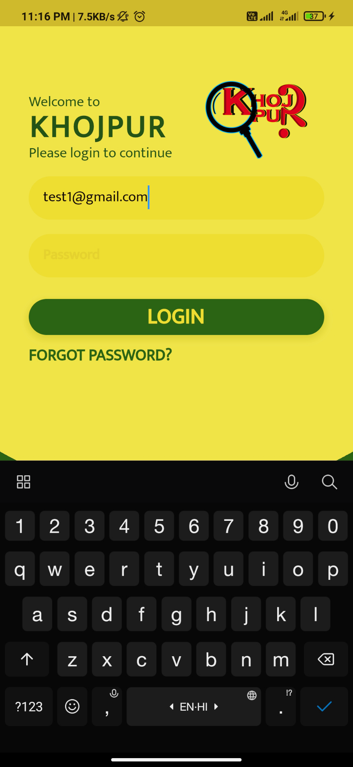

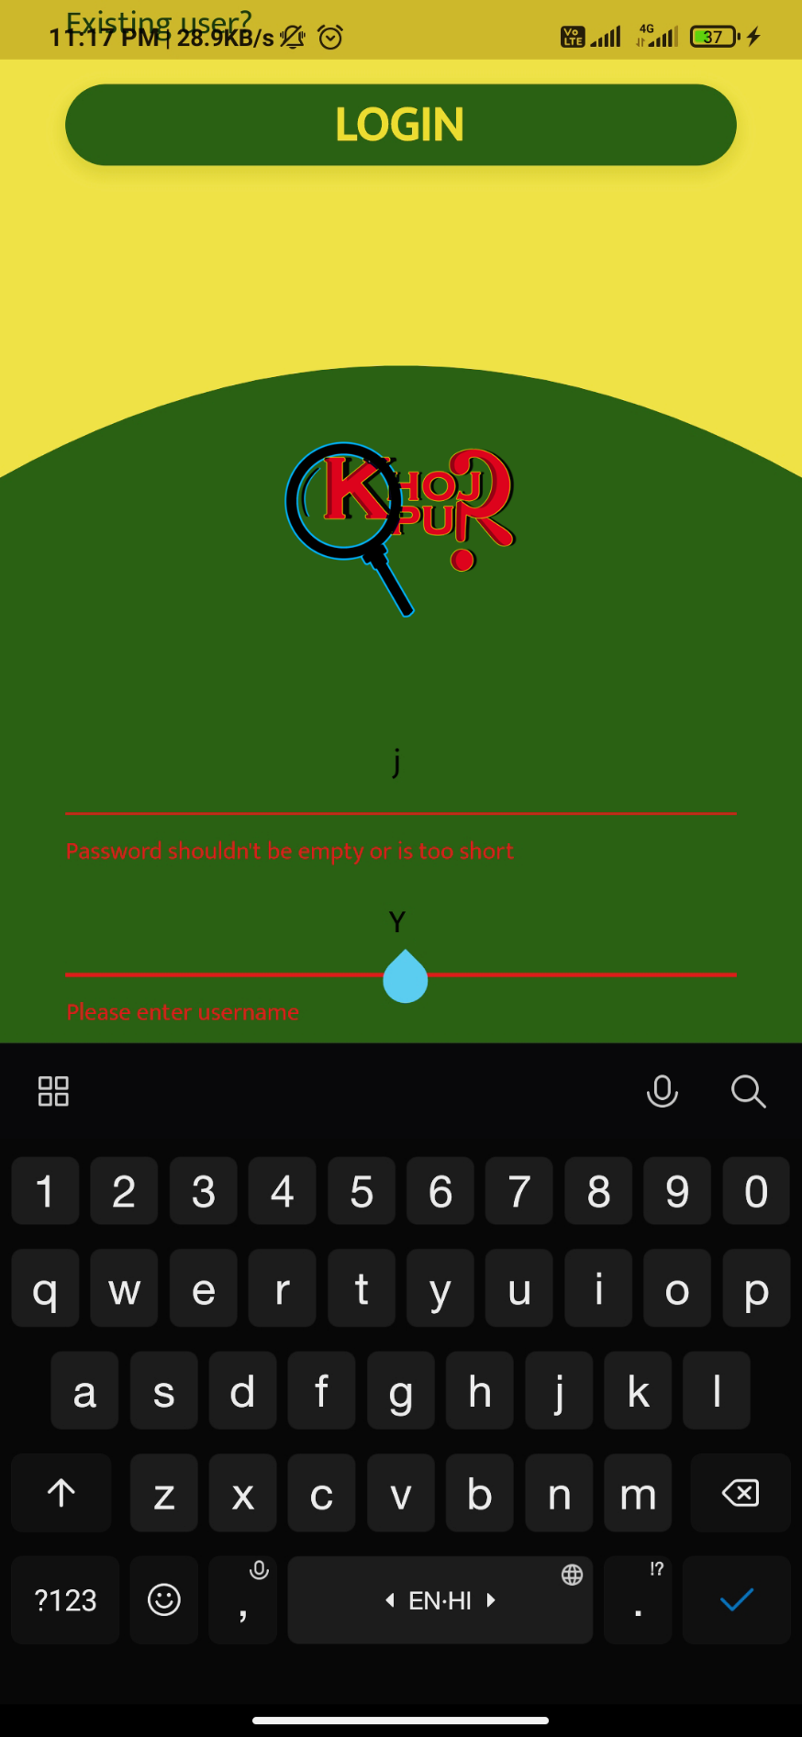

**References**

* Udemy’s course The Complete 2020 Flutter Development Bootcamp with Dart, Instructor: Dr. Angela Yu: *https://www.udemy.com/course/flutter-bootcamp-with-dart/*
* Book, Flutter in Action, Author: Eric Windmill
* Flutter cookbook: *https://flutter.dev/docs/cookbook*
* Flutter documentation: *https://flutter.dev/docs/*
* Medium Blog posts: [*https://medium.com/*](https://medium.com/)
* Wikipedia: [*https://www.wikipedia.org/*](https://www.wikipedia.org/)
* Google search engine.